- Home
- Partners
- Publications
- SRA
- Links
- News
- FAQ
- Consortium area
- Contact us

RENEB Memorandum of Understanding
Read more

Comments from the Advisory Board, Lisbon, December 2015.
The Advisory Board was delighted with the final outcome of the RENEB project. Dr Kulka, the co-ordinator, together with the Work Package and Task leaders and all contributing staff have brought the EU funded programme to a very successful conclusion.
Read more: Concludig remarks of the Advisory Board.

RENEB Final Meeting in Lisbon, December 2nd–4th, 2015
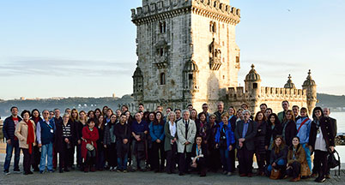
The final RENEB meeting took place in Lisbon at the Executive Art’s Hotel. Portuguese partners of RENEB organised this meeting. The RENEB consortium thanks Octávia Monteiro Gil and Pedro Vaz for the excellent organisation.
Read more

Dissemination event in Brussels, 26th November 2015
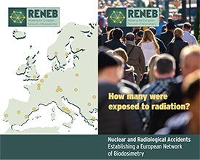
The RENEB Demonstrations event was held at the CDMA building of the EU Commission in Brussel on November 26th, 2015.
Read more

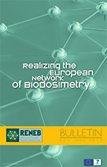

RENEB Bulletin no 3 was issued in the summer 2015
(pdf)

Comments from the Advisory Board, Rome, March 2015
The Advisory Board is very pleased with the progress to date. All activities due by this point in the programme have been achieved with reports and deliverables produced on time.
Read more

The Annual Meeting 2015
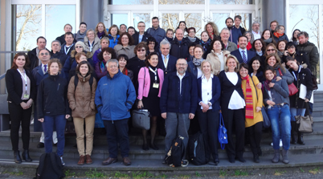
4th Annual meeting of RENEB was organized in Roma from 4th to 6th of March 2015 at the ENEA facilities.
The meeting was organized by Italian partners from ENEA and ISS.
Read more

Announcement

During the 41st Annual Meeting of the European Radiation Research Society, ERR2014, in Rhodes, Greece from 14th to 19th of September 2014 it will be organized RENEB project meeting.
Time: Tuesday, 16 September, 18.30 - 19.30.
This meeting will also be open to non RENEB ERR participants.

RENEB presentations on IRPA14, Geneva (23–27 June, 2014)
Ulrike Kulka presented RENEB in the session Emergencies, Safety and Security with the talk "RENEB –status Quo of the Biodosimetry Network"
Stephen Barnard presented RENEB exercise during the session Measurements & Dosimetry with the talk "Telescoring and laboratory inter-comparison exercise of the gamma-H2AX biodosimetry assay"
François Trompier et al. presented poster PS3-2/06 "Overview of physical dosimetry methods for triage application integrated in the new European network RENEB" This poster had been selected as one of four posters out of some hundreds for IRPA poster price.
Link to the poster

RENEB poster on IRPA conference under session «Emergency Exposure Situations - Emergency Preparedness and Response»

Download poster here

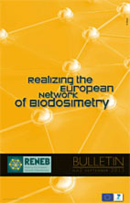

RENEB Bulletin no 2 was issued in September 2013 (pdf)

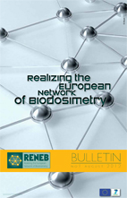

RENEB Bulletin no 1 was issued in August 2012 (pdf)

Reporting sheet for potential new members and new technologies in RENEB
Information for potential new members.
RENEB is an EU project with the aim to create a network of biological dosimetry within 4 years (2012 to 2015). During this installation period, it will not be possible to integrate new members or methodologies in the network. From the time RENEB is a legal organisation, additional members or methodologies can apply for a membership.
Reporting sheet for new members.
Information for the recommendation of new methodologies.
Reporting sheet for new technologies.

